1.Draw a labeled diagram of a Cat6 Ethernet cable, showing the color order of wires in the T568B standard and labeling the RJ-45 connector pins

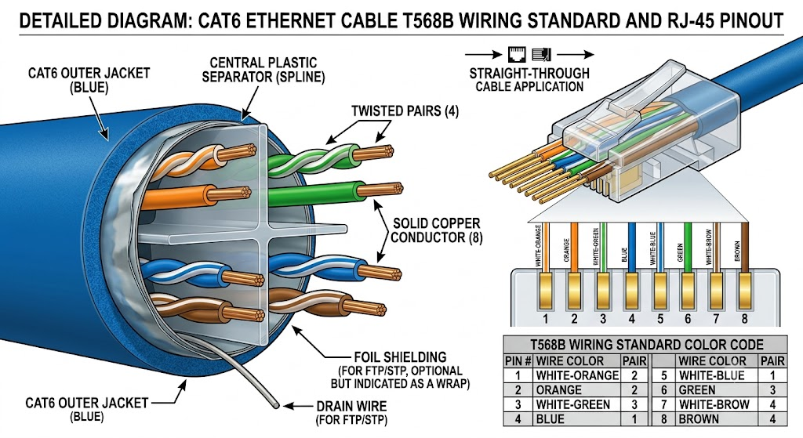

2.List three types of network cables (such as Cat5e, Cat6, and fiber optic) and for each, mention one real-world app or device (like a WiFi router, Zomato POS terminal, or IPL streaming server) where it would be used, explaining why.

Here are three types of network cables, along with a real-world device they connect and the reason why:
1. Cat5e (Category 5e)
- Real-World Device: Zomato POS (Point of Sale) Terminal
- Why It's Used: Cat5e supports speeds up to 1 Gbps, which is more than enough bandwidth to handle quick, low-data transactions like processing food orders, syncing inventory, and managing payments in a restaurant. It is also highly cost-effective for retail environments.
2. Cat6 (Category 6)
- Real-World Device: Home WiFi 6 Router
- Why It's Used: Cat6 cables handle speeds up to 10 Gbps over shorter distances and feature stricter crosstalk specifications. This makes them ideal for connecting a modern home router to a modem, ensuring it can handle simultaneous high-bandwidth activities like 4K streaming and online gaming without interference.
3. Fiber Optic Cable
- Real-World Device: IPL (Indian Premier League) Live Streaming Server
- Why It's Used: Fiber optic cables use light to transmit data, providing massive bandwidth (100+ Gbps) and near-zero latency over long distances. This is critical for streaming servers that must instantly broadcast live, high-definition video feeds to millions of concurrent viewers without lagging.

3.Watch a YouTube video showing how to crimp an RJ-45 connector onto a network cable, then write down the step-by-step process in your own words and mention two common mistakes to avoid.
Creating your own Ethernet cables allows you to customize lengths for cleaner cable management and repair broken connectors without replacing the entire cable run. This guide covers crimping a standard "straight-through" cable using the T568B wiring standard.
While there are two wiring standards (T568A and T568B), T568B is the most common standard for commercial and residential data networks in the US and Europe. It is critical that both ends of your cable use the same standard to function correctly.
Step 1 Prepare the Cable
- Insert the cable into the stripper's designated slot.
- Rotate the tool 360 degrees around the cable to score the outer jacket.
- Tip: Be gentle. You only want to cut the outer plastic jacket, not the delicate copper wires inside.
- Pull the outer jacket off to reveal the internal wires. You should expose about 1.5 to 2 inches (4-5 cm) of wire

Step 2 Untwist and Organize
- You will see four twisted pairs of wires. Untwist them completely so you have 8 separate wires.
- Straighten the wires as much as possible using your fingers or the shaft of a screwdriver.
- Cut off the "rip cord" (the thin thread inside the cable) if present, so it doesn't get in the way.

Step 3 Arrange the Color Code (T568B)
Arrange the wires flat, side-by-side, from left to right according to the T568B standard: White/Orange - Orange - White/Green - Blue - White/Blue - Green - White/Brown – Brown
Step 4 Trim the Wires
- Hold the wires tightly between your thumb and forefinger to keep them flat and in order.
- Use your wire cutters (or the cutting blade on your crimper) to trim the wires in a perfectly straight line.
- You should leave about 0.5 inches (1.3 cm) of exposed wire.

Step 5 Insert Wires into the Connector
- Hold the RJ45 connector with the clip facing away from you (gold pins facing up).
- Carefully push the wires into the connector. Ensure they stay in the correct order (White/Orange on the left).
- Push until you see the copper ends of the wires touching the very front of the plastic plug.
- Look at the side of the connector: The cable's outer jacket should be inserted past the indentation near the rear of the plug. This ensures the crimp secures the jacket, not just the wires.

Step 6 Crimp the Connector
- Insert the connector fully into the "8P" slot of your crimping tool.
- Squeeze the handles firmly until the tool releases (if ratcheted) or until you can't squeeze any further.
- The tool pushes the gold contacts down into the wires and crushes the plastic tab onto the cable jacket for strain relief

Step 7 Inspect and Test
- Remove the connector from the tool. Check the pins: they should all be pushed down evenly.
- Repeat the entire process for the other end of the cable.
4.Given the following scenario: You are setting up a gaming zone for an IPL screening event and need to connect multiple screens and consoles. Choose the appropriate cable and connector types for high-speed, reliable connections, and explain your choices.

Connection Type | Recommended Cable | Connector | Max Ideal Distance | Purpose
Console to TV | HDMI 2.1 (Ultra High Speed) | HDMI Type A | < 5 meters | $4K$ @ $120\text{ Hz}$ gaming, VRR, low latency
Long Run to Display | Cat6 STP (via HDBaseT) or AOC | RJ45 / HDMI | Up to 100 meters | Distributing the IPL broadcast across the venue
Internet / LAN | Cat6 Ethernet | RJ45 | Up to 100 meters | Eliminating Wi-Fi lag for online gaming
Main Sound System | XLR | 3-pin XLR | Highly extended | Interference-free match commentary

5.Find and share a photo (from your home, college, or online) of any network cable or connector in use (such as behind a WiFi router or at a café's POS counter), and describe what type it is and what devices it connects.<br><br><em><strong>Hint:</strong> Look for blue or yellow cables with clear plastic ends (RJ-45) or thin round cables for fiber optics.</em>

Here is a look at a standard network setup you will often see in a home or office:

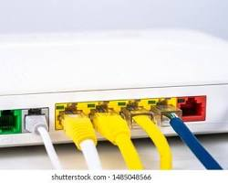
Cable Type: Ethernet (Cat5e or Cat6)

This is a classic Ethernet cable (often a Cat5e or Cat6 variety) featuring a clear plastic RJ-45 connector snapped firmly into place. The distinctive plastic clip on top locks it in so the connection doesn't drop if the cable gets pulled.

